mohamed karim
[Email address]
Abstract
The project will attempt to apply two machine learning algorithms (Logistic Regression and Naïve Bayes) to performing text classification on two datasets (the IMDB Movie Reviews Data Set and the SMS Spam Data Set). The text data was preprocessed and converted into numerical features using the TF-IDF vectorization technique prior to training and testing both models to determine which performed better, (with accuracy being the primary metrics). The results of this experiment showed that Naïve Bayes out-performed Logistic Regression on the SMS spam dataset because SMS messages are shorter and simpler than IMDB reviews; conversely, Logistic Regression outperformed Naïve Bayes on the IMDB data set, largely because IMDB movie reviews are longer and more complicated than SMS text messages. Overall, this study will provide a demonstration of how various machine learning algorithms can perform differently on various types of data, as well as the need to select the best method for the characteristics of the dataset being evaluated.
Machine Learning Report
By: MOHAMED KARIM & REG : 221010054

The purpose of this research project is to develop and evaluate two supervised machine learning algorithms, Logistic Regression and Naive Bayes classifier, in order to perform text classification tasks.
The data sets used include:
- IMDB Movie Reviews Dataset
- SMS Spam Dataset

The objective of this study is to compare the accuracy of both algorithms, as well as analyze results obtained from this comparison.

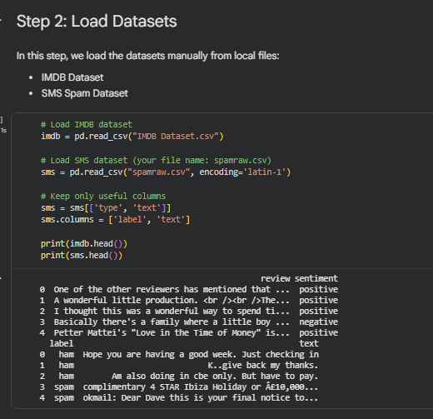

2. Dataset Description
IMDB Dataset
The IMDB dataset contains movie reviews labeled as:
- Positive
- Negative
This is a binary classification problem where the model predicts the sentiment of each review.

SMS Spam Dataset
The SMS dataset contains messages labeled as:
- Spam
- Ham (not spam)
This is also a binary classification task.

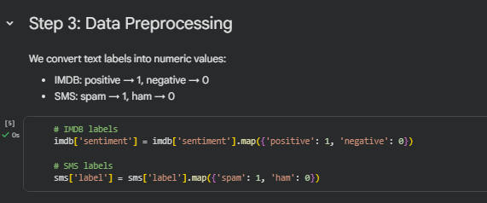

3. Data Preprocessing
In this step, the text labels were converted into numerical values:
- IMDB:
  - positive → 1
  - negative → 0
- SMS:
  - spam → 1
  - ham → 0
This transformation is necessary because machine learning models work with numerical data.

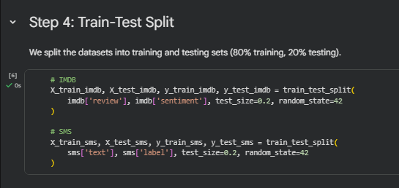

4. Train-Test Split
The datasets were split into:
- 80% training data
- 20% testing data
This allows the model to learn from training data and be evaluated on unseen data.

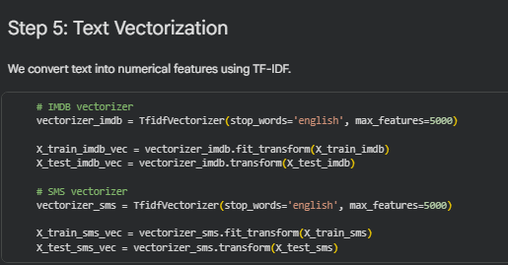

5. Text Vectorization
Text data cannot be used directly, so it was converted into numerical features using TF-IDF (Term Frequency - Inverse Document Frequency).
TF-IDF helps in:
- Giving importance to important words
- Reducing the impact of common words

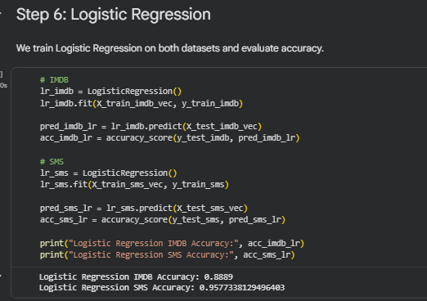

6. Logistic Regression
Logistic Regression was trained on both datasets.
Results:
- IMDB Accuracy: 0.8889
- SMS Accuracy: 0.9577
This model performed well, especially on the SMS dataset.

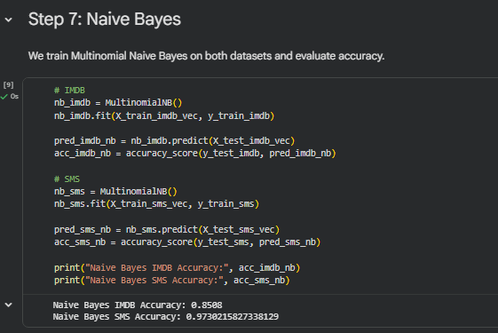

7. Naive Bayes
Naive Bayes was also trained on both datasets.
Results:
- IMDB Accuracy: 0.8508
- SMS Accuracy: 0.9730
Naive Bayes performed better on the SMS dataset.

8. Model Comparison
All models were compared based on accuracy:
Model | Accuracy
Naive Bayes (SMS) | 0.9730
Logistic Regression (SMS) | 0.9577
Logistic Regression (IMDB) | 0.8889
Naive Bayes (IMDB) | 0.8508

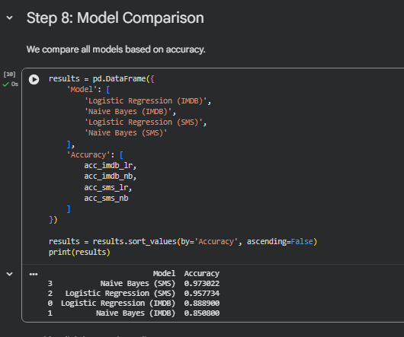

9. Ranking
The models are ranked from best to worst:
- Naive Bayes (SMS)
- Logistic Regression (SMS)
- Logistic Regression (IMDB)
- Naive Bayes (IMDB)

10. Results
The SMS dataset had a high accuracy rate for the Naive Bayes classifier because the SMS dataset is easier. On the IMDB dataset, Logistic Regression achieved the highest accuracy due to IMDB's more complex, longer reviews.
. Explanation of Results
- Naive Bayes performed best on the SMS dataset because the dataset is simple and contains short texts.
- Logistic Regression performed better on the IMDB dataset because it handles complex and high-dimensional data better.
- IMDB dataset is more difficult due to long reviews and complex language.
- SMS dataset is easier because messages are short and more structured.

11. Conclusion
In this research, both the Naive Bayes and Logistic Regression models were utilized with success.
The Naive Bayes model has the highest average accuracy across both datasets and the Logistic Regression model performs extremely well with more complex types of data. Therefore, we can infer that the performance of a particular model will be dependent on the complexity of the data provided.

